HR ANALYTICS SYSTEM
(Employee Attrition & Performance Analysis Using Python, SQL & Tableau)
Prepared By:
Afifah Khatoon

TOOLS USED:
- Python (Pandas, NumPy, Matplotlib, Seaborn)
- SQL (basic queries)
- Tableau (Dashboard creation)
- Jupyter Notebook
- CSV / Excel dataset
ACKNOWLEDGEMENT:
I would like to express my gratitude to all online learning platforms, documentation, and resources that helped me complete this HR Analytics project.
This project helped me understand real-world data analysis using Python, SQL, and Tableau.

OBJECTIVE:
The objective of this project is to analyse employee data to:
- Understand employee attrition patterns
- Identify key reasons for employee resignation
- Analyse performance factors affecting productivity
- Build interactive dashboards using Tableau
- Practice real-world data analytics workflow

Dataset Source: The dataset used for this project is the public IBM HR Analytics Employee Attrition & Performance dataset.
Dataset Link: https://www.kaggle.com/datasets/pavansubhasht/ibm-hr-analytics-attrition-dataset

SQL Implementation:-
1.Headcount Analysis (Total Employees)
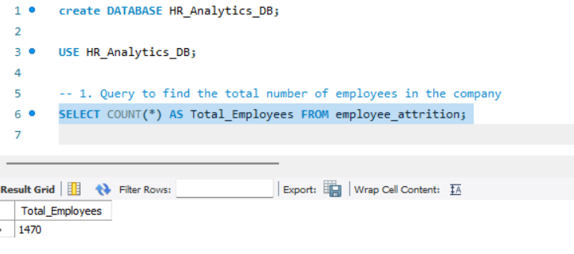
Explanation:-
This SQL query calculates the total number of employees currently recorded in the organization's database by counting the total rows in the table. It establishes the baseline headcount metric required to calculate the company's overall attrition rate.

2.Attrition Rate Analysis
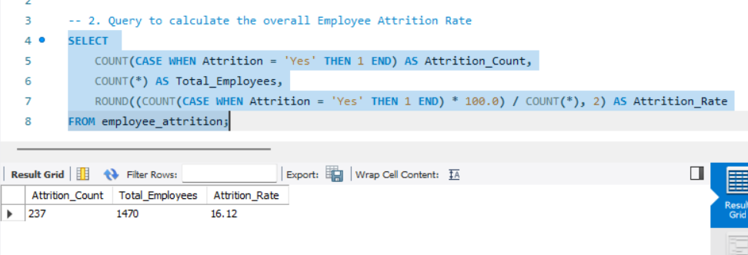
Explanation:-
This SQL query calculates the company's overall attrition rate by dividing the number of employees who left ('Yes') by the total workforce count. It provides a crucial percentage metric that helps HR leadership understand the severity of employee turnover across the organization.

3.Department-wise Attrition Breakdown
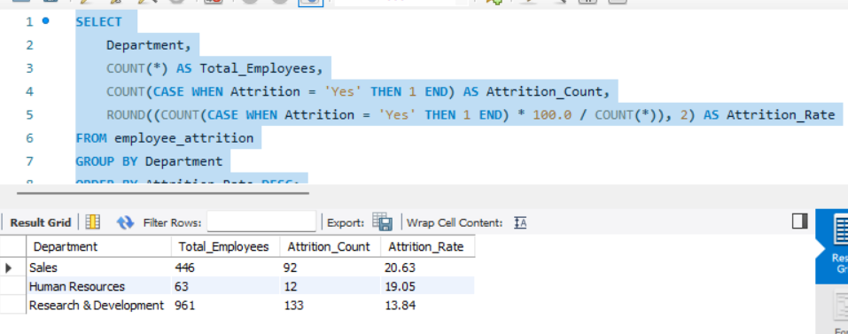
This SQL query groups the employee data by their respective departments to count the total exits and calculate the specific turnover rate for each sector. It highlights which department—such as R&D or Sales—is facing the most critical retention challenges, allowing for targeted HR interventions.

Python Implementation:-
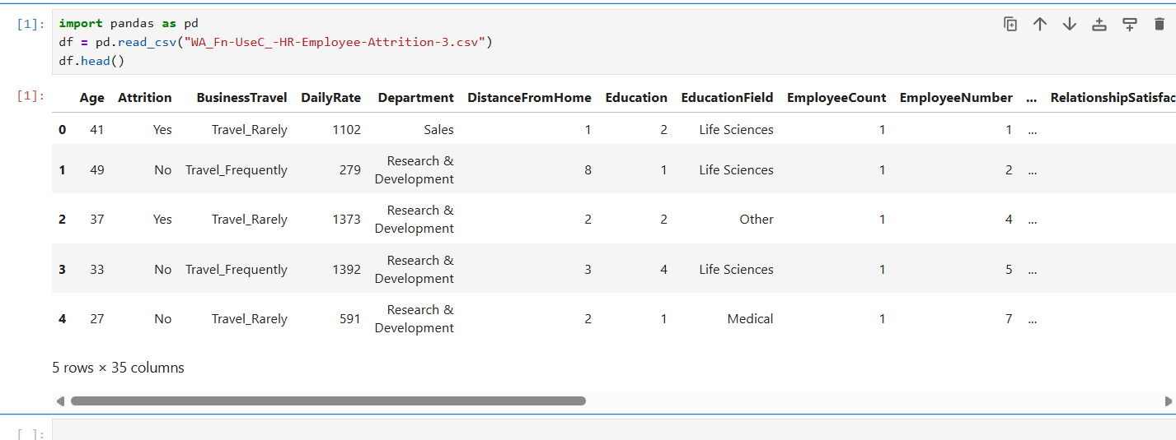
- Distribution of Employee Attrition:-
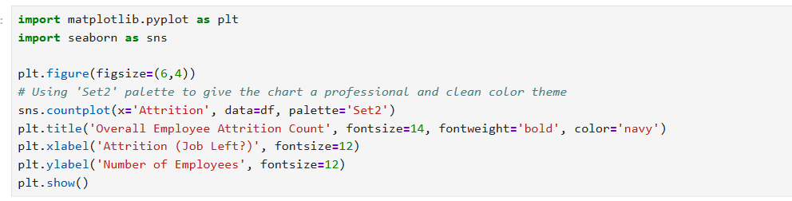
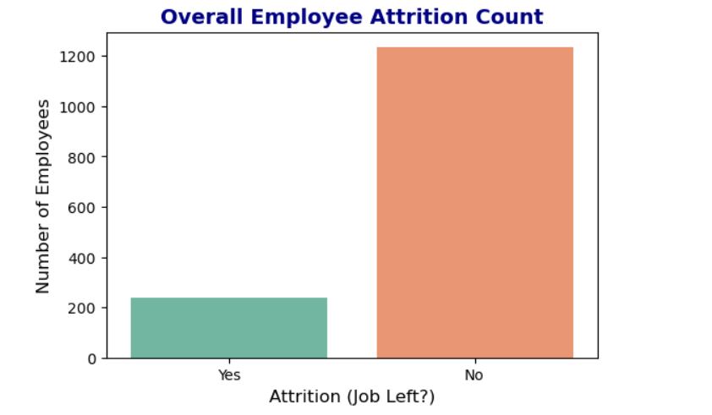
Explanation:-
This Python script utilizes the Seaborn library to generate a bar chart visualizing the distribution of active versus departed employees. It provides a quick, visual comparison of the retention balance, making it easier for stakeholders to see the exact ratio of employee exits.

- Impact of Overtime on Employee Turnover:-
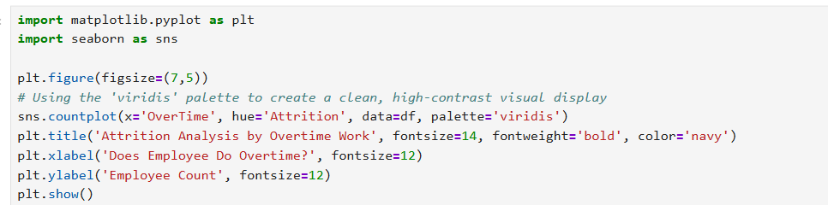
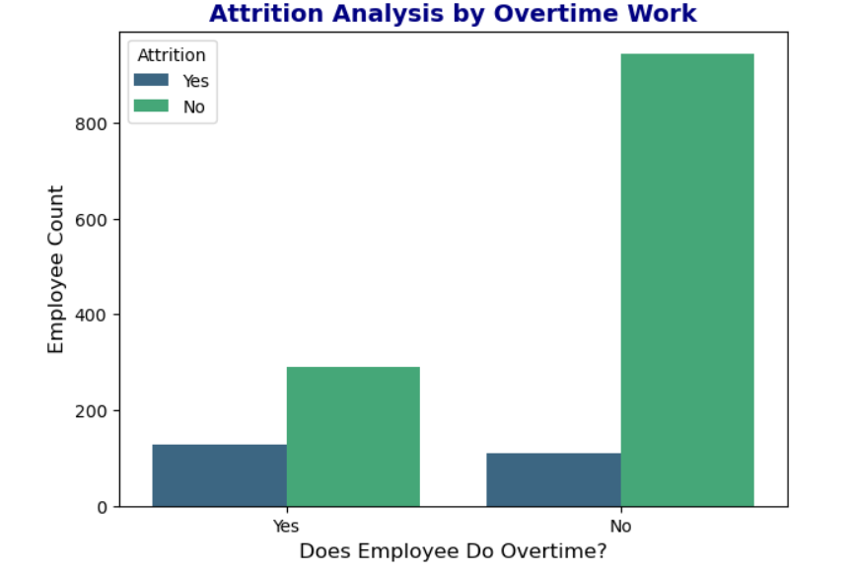
Explanation:-
This Python script generates a grouped bar chart to analyze the direct relationship between employee overtime work and overall turnover. It allows HR teams to easily compare attrition rates among overtime workers versus standard workers, highlighting workload stress as a potential retention risk factor.

- Age Distribution Across Attrition Groups:-
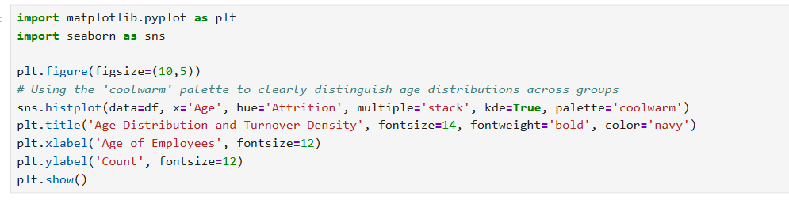

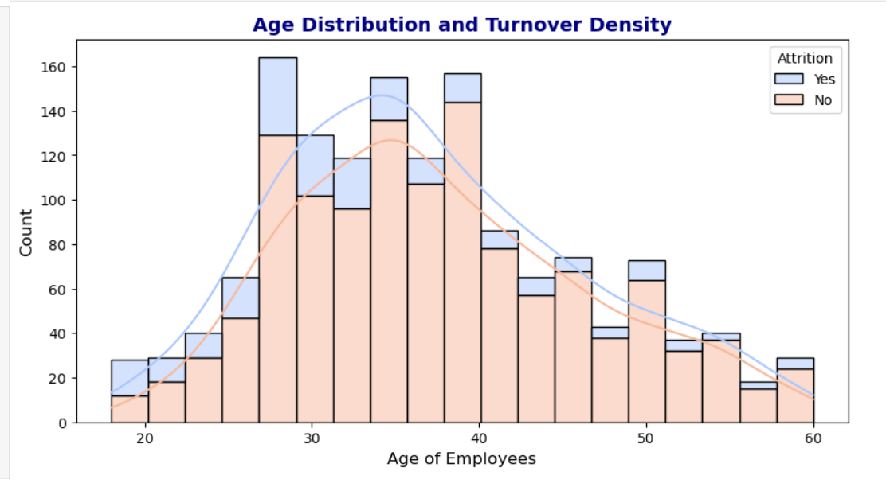
Explanation:-
This Python script creates a stacked histogram with a Kernel Density Estimate (KDE) curve to show the age distribution of employees alongside their attrition status. It effectively highlights the specific age bands—such as early career professionals—where employee turnover is most heavily concentrated.

Tableau Dashboard:-
Department-wise Employee Attrition Breakdown:-
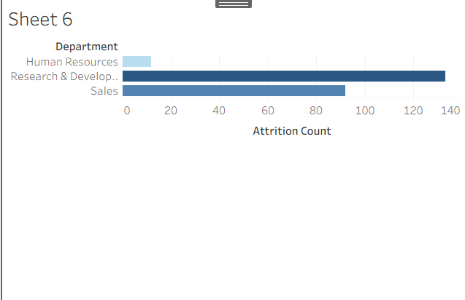

Explanation:-
This dashboard provides a high-level overview of the company's total headcount and attrition trends across different departments. It helps the top leadership quickly identify which major sectors are losing the most talent.

Age Distribution & Attrition:-
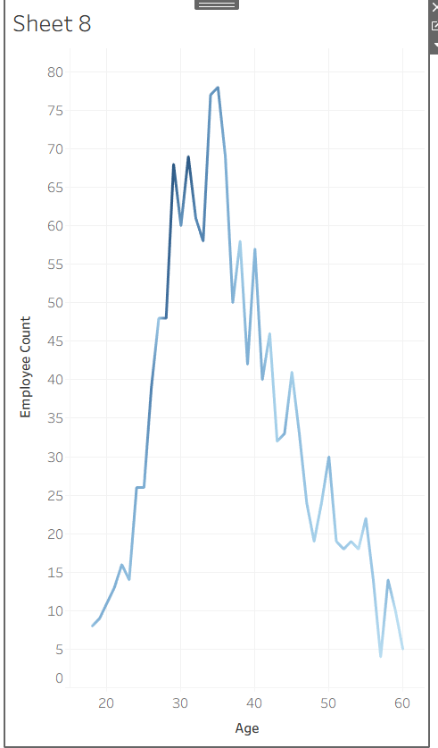
Explanation:-
This dashboard analyses how personal and social factors like age groups, gender, and marital status affect employee turnover. It highlights which specific demographic groups are at the highest risk of leaving the company.

Job Role Attrition Ranking:-

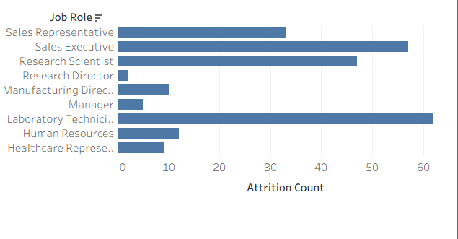
Explanation:-
This dashboard evaluates the workplace environment by linking different job levels, job roles, and overtime with employee satisfaction. It helps HR pinpoint exactly how work stress and seniority levels impact employee retention.

Monthly Income vs Age Distribution:-
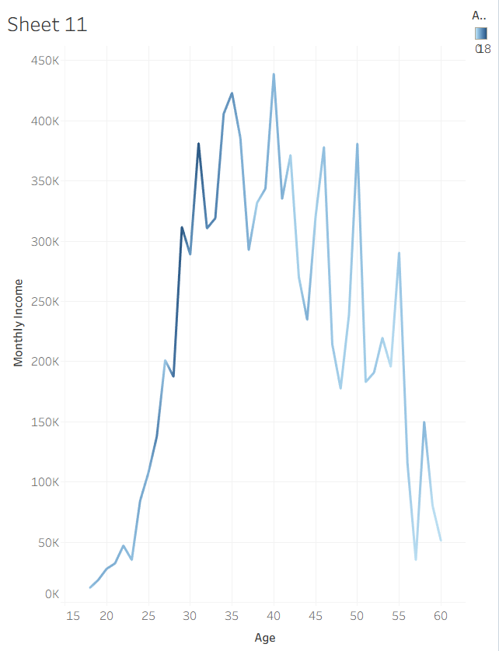
Explanation:-
This dashboard explores the financial correlation between an employee's monthly income, promotion history, and their decision to leave. It assists the finance and management teams in reviewing salary structures to control attrition.
Conclusion:-
This HR Analytics project used Python, SQL, and Tableau to analyse employee attendance, performance, salary, and attrition data. The analysis provided useful insights and demonstrated skills in data cleaning, data analysis, SQL queries, and dashboard creation. Overall, the project shows how data analytics can support better HR decision-making.

Thank You,

